Emergency Management
Procedures Handbook

Rainbow P 12 College
2023 Edition

Cover page
back

Table of Contents………………………………………………….…1
Overview of Procedures……………………………………………………….…………..…………..3
Role of the classroom teacher……………………………..……………………………..…………4
- On Site Evacuation………………………………………….………………………………..5
- Off Site Evacuation…………………………………………………….……..…….………..6
- Lock Down…………………………………………………………………….………………….7
- Lock Out…………………………………………………………………..……..………………..8
- Shelter in place………………………………………………………………….……………..9
- Earthquake……………………………………………………….………...………………….10
- Severe weather event……………………………………………….……….……………11
- Actions after an emergency………………………………………………….…………12
Role of ES and non teaching staff at the time……………………………….……………..13
- Chief Warden…………………………………………………………………………….…...14
- Administration / Business Manager…………………………………………….….15
- Door & room checker………………………………………………………………….….16
- Door Monitor……………………………………………………………………………….…17
- Emergency services liaison and main entry……………………………………..18
- First Aid………………………………………..…………………………………………………19
- Severe weather action team……………………..…………………………………….20
- Staff assistance……………………………………………………………….………………21
- Traffic & movement control…………………………………………….…………..…22
Incident Management team flowchart………………………………..……………………….23
IMT roles…………………………………………………………………..……………………..………….24
Debriefing after an incident……………………………………………..………………………….26
Bomb Threat: what to say & do……………………..…………………………………………….27
Basic First Aid………………………………………………………….…………………………………..33

Table of Contents Continued..
Map of the school……………………………………….………….……………………………………34
Off Site Evacuation Map……………………………………….……………………………………..35
Important phone numbers……………………………….………………………………………….36

Overview of Procedures

The main purpose of this book is to act as a reminder, guide and checklist to make sure that we are following the Emergency management plan in the most effective and thorough way possible.

This booklet is divided into 2 main sections:
The role of classroom teachers
&
The role of other staff who are not in charge if a class at the time of the incident.

Copies are situated in the Administration Building, Junior Building, Multipurpose Room, Hall and Tech Wing while we are under construction.

Role of the classroom teacher

Your main duty of care is to the safety of the students under your control.

For all types of incidents:
- Stop what you are doing.
- Determine what type of Emergency response is needed.
- Stay calm and explain to the students what will happens next.

On site Evacuation

- Close all windows and turn off lights, A/C etc.
- Students line up & leave the room via the EMERGENCY EXIT. Remain in a group
Remind students to NOT collect books and items. Leave immediately.
- Close the door on exit and place a chair at the door (lets everyone know that the room is clear of people)
- Assemble at the artificial football turf area on the north side of the Hall (site A)
- If the incident is in the Tech wing or Hall area Evacuation will change to OFF SITE EVACUATION procedures.
- KEEP YOUR CLASS TOGETHER AT ALL TIMES!
- Once at the evacuation area (football oval) line students up in Year Levels & check roll.
- Wait for further instructions or until the ALL CLEAR is given.

Off Site Evacuation

- Close all windows and turn off lights, A/C etc.
- Students to line up & leave the room via the EMERGENCY EXIT. Remain in a group
- Remind students to NOT collect books and items. Leave immediately.
- Close the door on exit and place a chair at the door (lets everyone know that the room is clear of people)
- KEEP YOUR CLASS TOGETHER AT ALL TIMES! and direct to Mecca, depending on incident location.
- Gather at EVACUATION point and leave via McKenzie Lane behind the basketball court.
- Gather at ALBERT ST exit and take King St.
- Gather at bus shed near Tech wing and take QUEEN ST / King St.
- Once at the MECCA line students up outside and check roll.
- Enter MECCA and always stay in Year Level groups.
- Wait for further instructions or until the ALL CLEAR is given.

LOCKDOWN
- If class is outside go to nearest building.
- If before class, at recess or lunchtime go to the nearest building.
- Ask students to get under tables or in an area that is below window level or move to corridor.
- Keep students away from windows,
(in case of broken glass)
- Staff to check roll and note any students that have left the classroom and where they would have been.
- KEEP NOISE TO A MINIMUM!
- Remain calm so panic and anxiety is kept minimal.
- Lock Doors
- Wait for ALL CLEAR or further instructions.

Lock Out

Refer to Off Site Evaluation procedure.

Pg 6

SHELTER IN PLACE

- PA system will announce Shelter in Place to direct all staff and students to the school hall.
- JUNIOR STAFF- get students to line up and leave the room via the emergency exit point.
- SENIOR STAFF- ask the students to leave the room as a group via the emergency exit point.
- Students are to leave IMMEDIATELY and not to collect items or books.
- Put a chair outside the room and close the door/ windows to indicate the room is clear for emergency services / chief warden.
- Always keep your class together.
- Junior students on stage, Senior students on the court area away from windows.
- Line students up in alphabetical order in their year level.
- Elective or VCE subjects – is the teachers responsibility to check the class roll.
- Homeroom teachers will then check SENIOR year level lists on compass.
- Any absences will be immediately reported to Admin who will check Compass for any staff / students out of the school.
- Wait for further instructions.

Earthquake

If possible, the PA system will be used to alert staff and students to the event of an earthquake.
If Inside
- Move away from windows, heavy objects, shelves etc.
DROP, COVER & HOLD
- DROP to the ground.
- Take COVER by getting under a table or other piece of furniture or go into the corner of the building and cover face and head with arms.
- HOLD on until the shaking stops.
If Outside
- Stay outside and move away from buildings and utility wires.
DROP, COVER & HOLD
- DROP to the ground.
- Take COVER by covering your head and neck with arms and hands.
- HOLD on until the shaking stops.
- Follow EVACUATION procedure.
- Check on students after the shaking has stopped
- Complete a Roll and check for any injuries and structural damage.
- wait for further instruction.

Severe weather event

Refer to Lockdown procedures on
Pg 6

(Make sure all curtains & blinds are closed)

Also refer to,
Severe Weather Action Team
Pg 19
Actions after an Emergency
- Check for any physical injuries and report them to the first aid officers immediately.
- Check for any heighted levels of stress & anxiety and report them to the student management team immediately.
- Check in on other staff and on your own wellbeing (if you are concerned about another staff member or your own health report it to the leadership team immediately)
- Students may want to talk about has happened or they may have a million questions…a coordinated response will be prepared, and resources given to staff prepared to talk to students about the incident (if you feel uneasy in this situation, please do not put yourself in the uncomfortable position).
- If possible, try to restore some normality to the situation by getting back some type of routine as quickly as possible.
- The contacting of parents and other authorities is the role of the Chief Warden – your main priority is the duty of care to your students.
- Complete a post emergency record.

Role of ES, non teaching staff & teachers not teaching students at the time.

Your main role is logistics and supporting the classroom teacher in completing their job.
You MUST report to the Main Office
To be allocated a role.

(Unless that is the source of the issue)
Chief Warden

- Responsible for the Coordination of all aspects of an incident response
- Delegate roles to staff not teaching at the time of the incident.
- Delegate roles to the IMT when activated.
- Communicate with emergency services, DET, media & outside agencies.
- Communicate with staff, students & parents.
- Coordinate debriefing sessions.
- Evaluate response & collate feedback.

Administration / Business Manager

- Take the students attendance list, staff attendance and this plan to the evacuation site.
- All staff should report to you in regards of rolls taken and student attendance checked.
- Any absences will be immediately reported to Administration staff who will check compass for any students/staff out of the school.

Door & room checker

For Evacuations & Lockdowns

- Check rooms to make sure no one is left inside (call out and do a quick scan of the room).
- Check that all external doors (and windows) are locked.

-This is made easier if chairs are placed outside the door of the evacuated rooms.

Door Monitor

For Lockdowns & Shelter in Place

- You will be posted at locked doors to allow students, staff and visitors to enter if locked out.

Emergency services liaison & main entry access point

- It is your responsibility to wait at the main entry point of the school (if safe to do so) to guide emergency services personnel to the site of the incident.

- In lock downs your role may also include monitoring the main access point so no unauthorised people are allowed access.

First Aid

- For evacuations you will grab the emergency kit and evacuate to the specific site.
- After an incident staff will report to you with any physical injuries that need treating.
- Depending on the severity of the injury you may either go to the injured or set up a central triage point in the junior building (near the first aid supplies cupboard).

Severe Weather Action Team

- This team will be called into action prior to an event.
- Store or secure loose items external to the building, such as outdoor furniture and rubbish bins.
- Secure windows and doors.
- If necessary, tape windows and glass entrances.
- Utilise boards and sandbags if required.
- Disconnect electrical equipment, cover it and move it away from windows.

Staff Assistance

You may be asked to step into a classroom teacher’s role (or help) if:
- They are part of the incident management team.
- It is a junior class and they need extra help.
- The staff member is incapacitated in any way.

Traffic & Movement Control

Off site evacuation x 4 if possible.

- For off site evacuations you will grab a yellow vest and be responsible for monitoring and stopping traffic as the students make their way to the Mecca via Albert street / King Street.
- There should be a staff member in a fluorescent vest at the front and back of the school group.

Incident Management Team (IMT) Flowchart

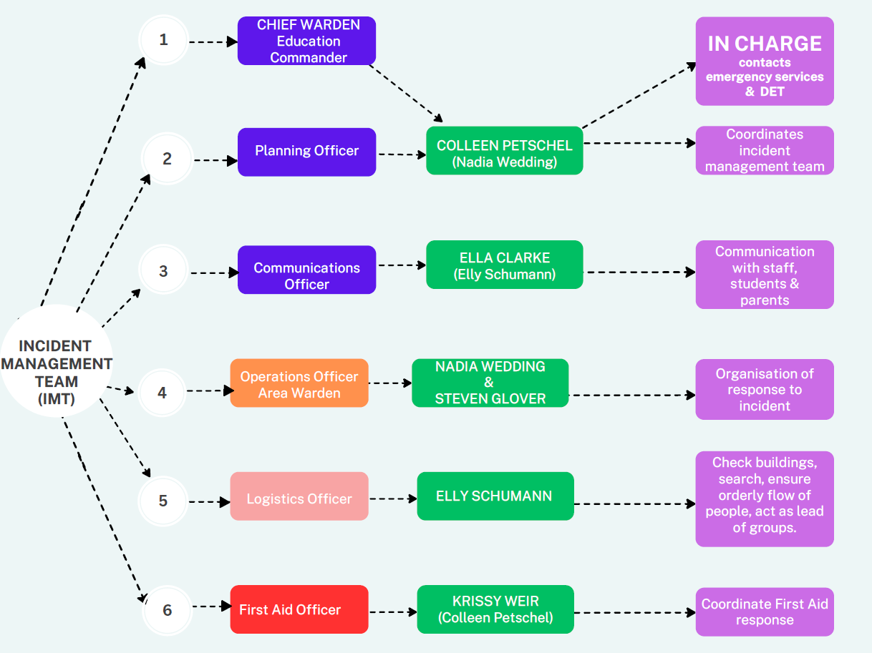

IMT Roles
Chief Warden (Colleen Petschel)
- In charge of the incident
- Contact Emergency services & DET

Planning Officer (Colleen Petschel)
- Coordinate the IMT (Incident Management Team)

Communications Officer (Ella Clarke)
- Main point of contact
- communicates with staff, students & parents

Operations Officer (Nadia Wedding & Steven Glover)
- Organise the response to the incident

Logistics Officer (Elly Schumann & Steven Glover)
- Check buildings & ensure an orderly flow of people

First Aid Officer (Krissy Weir)
- In charge of all first aid coordination

Debriefing after an incident
A debriefing is to allow staff to have the tie to process the event and work through any negative emotions. It can help staff talk about the personal impact of the traumatic event they have encountered.
Debriefing (powerful event group support) is usually carried out within 3 to 7 days of the crucial incident, when workers have had enough time to take in the experience. Debriefing is not counseling. It is a structured voluntary discussion aimed at putting an abnormal event into perspective. It offers workers clarity about the critical incident they have experienced and assists them to establish a process for recovery.

Trained debriefers help the workers to explore and understand a range of issues, including:
- The sequence of events
- The causes and consequences
- Each person's experience
- Any memories triggered by the incident
- Normal psychological reactions to critical incidents
- Methods to manage emotional responses resulting from a critical incident.

Bomb Threat: What to say and Do

BOMB/SUBSTANCE THREAT CHECKLIST
CALL TAKER |  |  |  | CALL TAKEN
Name: |  | Phone No: |  | Date of call: |  | Call Start/End Time:
Signature: |  |  |  | Number called: |  | Was call Local or STD:

BOMB THREAT QUESTIONS
When is the bomb going to explode?
Where did you put the bomb?
What does the bomb look like?
What kind of bomb is it?
What is in the bomb?
When did you put it there?
What will make the bomb explode?
Did you place the bomb?
Why did you put it there?
What is your name?
Where are you/what’s your address?
SUBSTANCE QUESTIONS
What kind of substance is in it?
When will the substance be released?
Where is it?
What does it look like?
When did you put it there?
How will the substance be released?
Is the substance liquid, powder or gas?
Did you put it there?
Why did you put it there?
What is your name?
Where are you/what’s your address?
CALLER’S VOICE
Sex of caller |  | Estimated Age
Accent (specify)
Speech impediments (specify)
Voice (loud, soft, etc)
Speech (fast, slow etc)
Dictation (clear, muffled etc)
Manner (calm, emotional, etc)
Did you recognise the voice? |  | If so, who do you think it was?
Was the caller familiar with the area?
THREAT LANGUAGE |  | BACKGROUND NOISE
Well spoken |  | Street noises
Incoherent |  | House noises
Irrational |  | Aircraft
Taped |  | Voices
Message read by caller |  | Music
Abusive |  | Machinery
Other: |  | Other
EXACT WORDING OF THREAT

ACTIONS
Report call immediately to: |  | Phone Number
Notes/Actions Taken

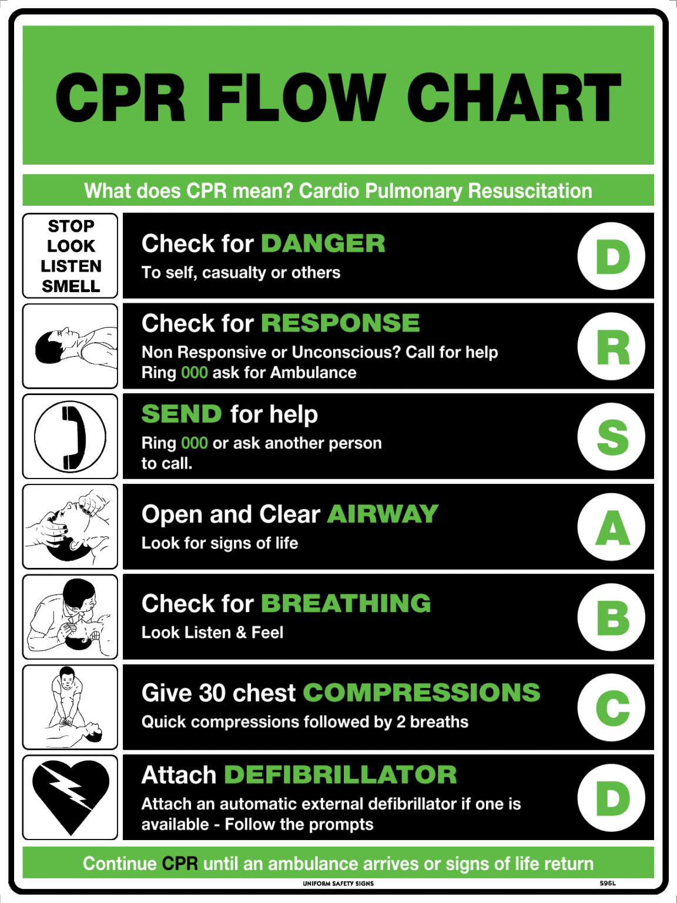
Basic First Aid

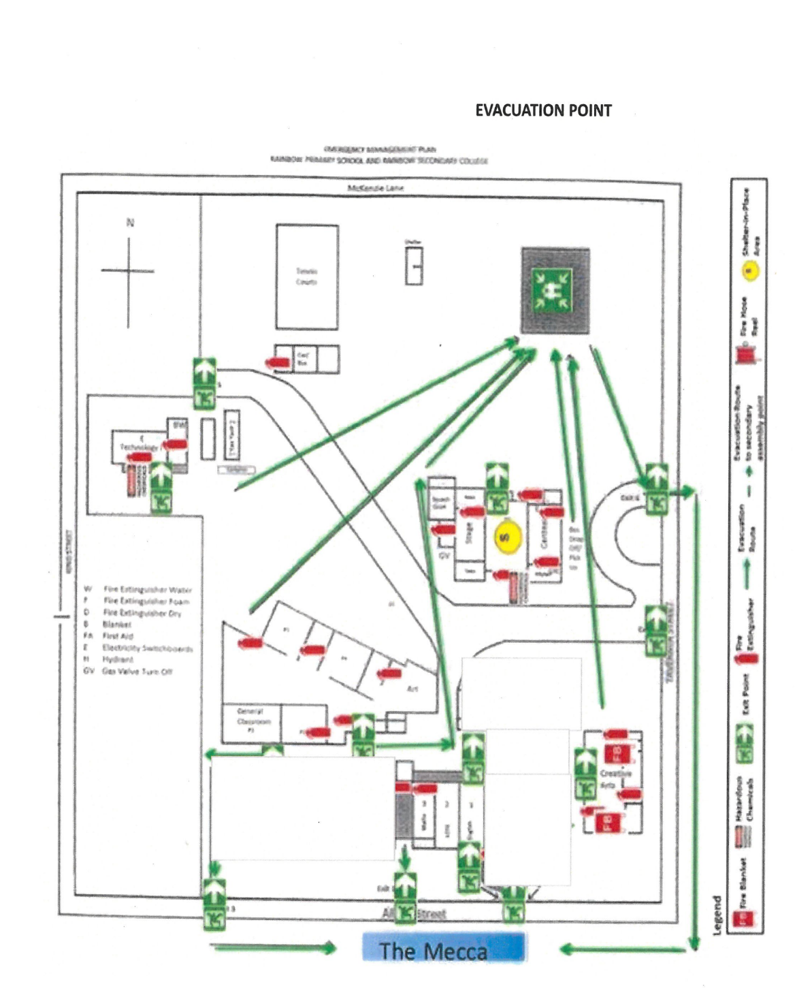
Map of the School

OFF SITE EVACUATION MAP
Site
A – Evacuation Area
B –
Exit gate in Albert St
C-
Exit gate at Bus shed (Queen St / King St)
D-
Laneway Off Site
Evacuation
(McKenzie Lane / King St)
C
D
B

A

Important Phone Numbers
Emergency Management Services | 95896266
Police | 000
Local Police Station | 53951051
Ambulance | 000
Fire | 000
Rainbow Hospital | 03 53963301
Gas - Elgas | 53511699
Electricity -Powercor | 132412
Water - GWM | 1300659961
DHS | 53918777
DHS Child Protection | 131278
Hindmarsh Shire | 53914444
EPA | 96952722
Regional Office | 53378444
Operations & Emergency Management -Andrea Cox?? | 43340509
SEIL - Jo Day | 0429601282
Employee Assistance Program | 1300361008

