Emergency
Management
Procedures
Rainbow P-12 College
2019 edition
Table of Contents
Overview of Procedures 3
Role of the classroom teacher 4
♦ On site evacuation/relocation…………………………. 5
♦ Off site evacuation……………………………………….. 6
♦ Lock down………………………………………………….. 7
♦ Lock out…………………………………………………….. 8
♦ Shelter in place……………………………………………. 9
♦ Earthquake………………………………………………… 10
♦ Severe weather event…………………………………… 11
♦ Actions after an emergency…………………………… 12

Role of ES & staff not teaching at the time 13
♦ Chief Warden……………………………………………….. 14
♦ Administration/Business Manager………………………. 15
♦ Door & room checker……………………………………… 16
♦ Door monitor………………………………………………… 17
♦ Emergency services liaison & main entry……………… 18
♦ First Aid……………………………………………………….. 19
♦ Severe weather action team…………………………….. 20
♦ Staff assistance……………………………………………… 21
♦ Traffic & movement control………………………………. 22
Incident Management team flowchart……………………… 23
IMT roles……………………………………………………………. 24
Debriefing after an incident……………………………………. 25
Bomb threat: what to say & do……………………………….. 26
Basic First Aid……………………………………………………… 29
Map of the school……………………………………………….. 30
Important phone numbers……………………………………… 31
Overview of Procedures
The main purpose of this book is to act as a reminder, guide and checklist to make sure that we are following the Emergency management plan in the most effective and thorough way possible.

This booklet is divided into two main sections:
The role of classroom teachers
&
The role of other staff who are not in charge of a class at the time of the incident

Role of the
Classroom teacher

Your main duty of care is to the safety of the students under your control

For all types of incidents:
• Stop what you are doing
• Determine what type of emergency response is needed
• Stay calm and explain to the students what will happen next

On-site evacuation/relocation

- The siren will be activated combining with the word evacuate (getting increasingly louder)
- If time permits close all windows, switch off lights, air conditioners, heaters etc
- For junior staff get the students to line up and leave the room via the emergency exit point
- For senior staff ask the students to leave the room as a group via the emergency exit point
- Remind students to leave immediately and not to collect items or books
- If time permits put a chair outside the room & close the door/windows to indicate to emergency services that the room is clear (collect individual first aid kits)
- Direct the students to the artificial football turf area on the north of the hall (SITE A)
- Keep your class together at all times
- get the students to line up in their class (in alphabetical order is preferred)..check hard copy roll
- If an elective or VCE subject it is the classroom teachers responsibility to check them on compass first
- Homeroom teachers will then check senior year level lists on compass
- Any absences will be immediately reported to Admin who will check passtab for any students/staff out of the school
- Wait for further instructions or until the alert states ALL CLEAR

Off-site evacuation

- If time permits close all windows, switch off lights, air conditioners, heaters etc
- If we are unable to use SITE A the PA system will be used to direct students to SITE B (Albert St on the road) staff in fluorescent vests will also direct students to the SITE B evacuation site
- For junior staff get the students to line up and leave the room via the emergency exit point
- For senior staff ask the students to leave the room as a group via the emergency exit point
- Remind students to leave immediately and not to collect items or books
- If time permits put a chair outside the external door & close the door/windows to indicate to emergency services that the room is clear (collect individual first aid kits)
- Direct the students to the nominated evacuation point (Albert street or artificial football turf area on the north of the hall)
- Keep your class together at all times
- get the students to line up in their class (in alphabetical order is preferred)
- If an elective or VCE subject it is the classroom teacher’s responsibility to check them on compass first
- Homeroom teachers will then check senior year level lists on compass
- Any absences will be immediately reported to Admin who will check passtab for any students/staff out of the school
- If SITE A is used students & staff will exit via the gates into the back lane
- Stay with your class and walk with the students to the Mecca in the main street.
- Once at the Mecca check rolls again (hard copy or compass)
- Wait for further instructions

Lock down procedure
- The alert siren will be activated and the word LOCKDOWN will be repeated
- If the alert system cannot be activated the PA system will be used and the following announcement will be made “Can Mr Brown please bring the purple chalk to the office”
- Stay in the classroom
- if the class is outside in the yard go to the nearest building
- if the lockdown occurs before school, at recess or lunchtime direct students to the nearest building
- Ask the students to get under the tables or in an area that is below window level, or move into corridors
- Try to keep students away from windows (in case of broken glass)
- Check attendance and note any students that may have left the classroom (and where they were going)
- It is important to keep noise to a minimum
- Ask senior students to stay off their phones and social media
- Check in on students in a calm manner as there could be a chance that panic and anxiety may occur
- Wait for further instructions or until the alert states ALL CLEAR

Lock out procedure

Refer to Off-site evacuation procedure
Page 6

Shelter in place
procedure

- The PA system will be used to direct all staff and students to the school hall/canteen area
- For junior staff get the students to line up and leave the room via the emergency exit point
- For senior staff ask the students to leave the room as a group via the emergency exit point
- Remind students to leave immediately and not to collect items or books
- If time put a chair outside the room & close the door/windows to indicate to emergency services that the room is clear
- Direct the students to the school hall/canteen
- Keep your class together at all times
- get the students to line up in their class (in alphabetical order is preferred)
- If an elective or VCE subject it is the classroom teacher’s responsibility to check them on compass first
- Homeroom teachers will then check senior year level lists on compass
- Any absences will be immediately reported to Admin who will check passtab for any students/staff out of the school
- Wait for further instructions

Earthquake
If possible, the PA system will be used to alert staff and students to the event of an earthquake

If inside
• move away from windows, heavy objects, shelves etc
• DROP, COVER & HOLD
• DROP to the ground
• Take COVER by getting under a table or other piece of furniture or go into the corner of the building covering their faces and head in their arms
• HOLD on until the shaking stops

if outside
• stay outside and move away from buildings and utility wires
• DROP, COVER & HOLD
• DROP to the ground
• Take COVER by covering your head and neck with their arms & hands
• HOLD on until the shaking stops

♦ Check on students after the shaking has stopped
♦ Complete a roll and check for injuries
♦ wait for further instructions

Severe weather event
Refer to lockdown procedures
Page 7
(make sure all curtains & blinds are closed)

Also refer to Severe Weather Action team
Page 20

Actions after an emergency incident has occurred
- Check for any physical injuries and report them to the first aid officers immediately
- Check for any heightened levels of stress & anxiety and report them to the student management team immediately
- Check in on other staff and on your own wellbeing (if you are concerned about another staff member or your own health
- report it to the leadership team immediately)
- Students may want to talk about what has happened or they may have a million questions…a co-ordinated response will be prepared, and resources given to staff prepared to talk to
- students about the incident (if you feel uneasy in this situation
- please do not put yourself in the uncomfortable position)
- If possible, try to restore some normality to the situation by getting back to some type of routine as quickly as possible.
- The contacting of parents and other authorities is the role of the Chief warden – your main priority is the duty of care to your
- students
- complete a post emergency record

Other staff
(not teaching or ES staff)

YOU MUST REPORT TO THE MAIN OFFICE TO BE ALLOCATED A ROLE
(unless that is the source of the issue)

Your main role is logistics and
supporting the classroom
teacher in completing their job

Chief Warden

- Responsible for the co-ordination of all aspects of an incident response
- Delegate roles to staff not teaching at the time of the incident
- Delegate roles to the IMT when activated
- Communicate with emergency services, DET, media & outside agencies
- Communicate with staff, students & parents
- Co-ordinate debriefing sessions
- Evaluate response & collate feedback

Business Manager/
Administration

- take the students attendance list, staff attendance list and this plan to the evacuation site
- all staff should report to you in regards of rolls taken and student attendance checked
- Any absences will be immediately reported to Admin who will check passtab for any students/staff out of the school

Door & room checker (evacuations & lockdowns)
- Check rooms to make sure no one is left inside (call out & do a quick scan of the room)
- Check that all external doors (and windows) are locked

Door monitor
(lockdown and shelter-in-place)
- You will be posted at locked doors to allow students, staff and visitors to enter if locked out

Emergency service
liaison & main entry
access point

- It is your responsibility to wait at the main entry point of the school (if safe to do so) to guide emergency services personnel to the site of the incident
- In lock downs your role may also include monitoring the main access point so no unauthorised people are allowed access

First aid
- For evacuations you will grab the emergency kit and evacuate to the specified site
- After an incident staff will report to you with any physical injuries that need treating
- Depending on the severity of the injury you may either go to the injured or set up a central triage point (senior staffroom and junior building – near first aid supplies)

Severe weather action team

- This team will be called into action prior to an event
- store or secure loose items external to the building, such as outdoor furniture and rubbish bins
- secure windows and doors
- if necessary tape windows and glass entrances
- Utilise boards and sandbags if required
- disconnect electrical equipment, cover it and move it away from windows

Staff assistance
You may be asked to step into a classroom teacher’s role (or help out) if:

• they are part of the Incident management team
• it is a junior class and they may need extra help
• the staff member is incapacitated in any way

Traffic & movement
control
(off site evacuation) x 4 if possible
- For off site evacuations you will grab a yellow vest and be responsible for monitoring and stopping traffic as the students make their way to the Mecca
- there should be a staff member in a fluorescent vest at the front and back of the school group

Incident management Team (IMT) Flowchart

IMT Roles
Chief Warden
♦ They are in charge of the incident
♦ They contact Emergency services & DET
Planning officer
♦ They co-ordinate the IMT
Communications Officer
♦ Their role is the main point of contact
♦ They communicate with staff, students & parents
Operations Officer
♦ They organise the response to the incident
Logistics Officer
♦ They check buildings & ensure an orderly flow of people
First Aid Officer
♦ They are in charge of all first aid co-ordination

Debriefing after an
Incident
A debriefing is to allow staff to have the time to process the event and work through any negative emotions. ... it can help staff talk about the personal impact of a traumatic event they participated in.
Debriefing (powerful event group support) is usually carried out within three to seven days of the critical incident, when workers have had enough time to take in the experience. Debriefing is not counselling. It is a structured voluntary discussion aimed at putting an abnormal event into perspective. It offers workers clarity about the critical incident they have experienced and assists them to establish a process for recovery.
Trained debriefers help the workers to explore and understand a range of issues, including:
• The sequence of events
• The causes and consequences
• Each person’s experience
• Any memories triggered by the incident
• Normal psychological reactions to critical incidents
• Methods to manage emotional responses resulting from a critical incident.

Bomb Threat
CALL TAKER |  |  |  | CALL TAKEN
Name: |  | Phone No: |  | Date of call: |  | Call Start/End Time:
Sign |  |  |  | Number called: |  | Was call Local or STD:

CALLER’S VOICE
Sex of caller |  | Estimated Age
Accent (specify)
Speech impediments (specify)
Voice (loud, soft, etc)
Speech (fast, slow etc)
Dictation (clear, muffled etc)
Manner (calm, emotional, etc)
Did you recognise the voice? |  | If so, who do you think it was?
Was the caller familiar with the area?

THREAT LANGUAGE |  | BACKGROUND NOISE
Well spoken |  | Street noises
Incoherent |  | House noises
Irrational |  | Aircraft
Taped |  | Voices
Message read by caller |  | Music
Abusive |  | Machinery
Other: |  | Other

BOMB THREAT QUESTIONS
When is the bomb going to explode?
Where did you put the bomb?
What does the bomb look like?
What kind of bomb is it?
What is in the bomb?
When did you put it there?
What will make the bomb explode?
Did you place the bomb?
Why did you put it there?
What is your name?
Where are you/what’s your address?
SUBSTANCE QUESTIONS
What kind of substance is in it?
When will the substance be released?
Where is it?
What does it look like?
When did you put it there?
How will the substance be released?
Is the substance liquid, powder or gas?
Did you put it there?
Why did you put it there?
What is your name?
Where are you/what’s your address?

BOMB THREAT QUESTIONS
When is the bomb going to explode?
Where did you put the bomb?
What does the bomb look like?
What kind of bomb is it?
What is in the bomb?
When did you put it there?
What will make the bomb explode?
Did you place the bomb?
Why did you put it there?
What is your name?
Where are you/what’s your address?
SUBSTANCE QUESTIONS
What kind of substance is in it?
When will the substance be released?
Where is it?
What does it look like?
When did you put it there?
How will the substance be released?
Is the substance liquid, powder or gas?
Did you put it there?
Why did you put it there?
What is your name?
Where are you/what’s your address?
Bomb Threat continued

Bomb Threat continued

EXACT WORDING OF THREAT
ACTIONS

Report call immediately to: |  | Phone Number
Notes/Actions Taken

Basic first Aid

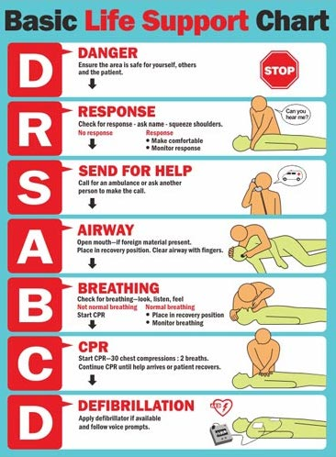
Map of the school

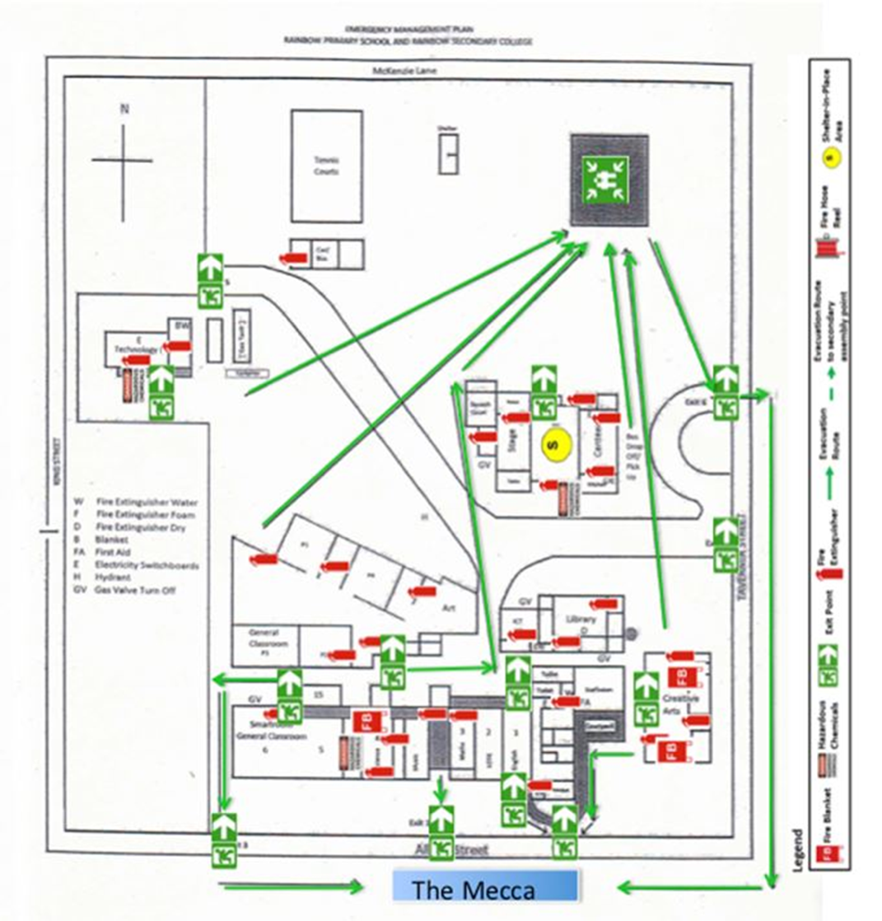

Important Phone numbers

Emergency Management  Services | 0395896266
Police | 000
Local police station | 53951051
Ambulance | 000
Fire | 000
Hospital | 53963300
Gas—Elgas | 53511699
Electricity—Powercor | 132412
Water—GWM | 1300659961
DHS | 53918777
DHS—Child Protection | 131278
Hindmarsh Shire | 53914444
EPA | 0396952722
Regional office | 53378444
Operations & Emergency  Management—Andrea Cox | 0343340509  0407861841
SEIL—Jo Day | 0429601282
Employee Assistance program | 1300361008

