The Workplace Manager and/or Management OHS Nominee are to develop a Traffic Management Plan (TMP) by considering the traffic management issues that are unique to their school/workplace in consultation with the HSR and employees. Reference should be made to the Traffic Management Procedure for assistance in completing the TMP.

The TMP template includes prompts on common risk controls for managing traffic in order to assist in the development of your workplace TMP. The TMP template should be reviewed and amended to reflect specific traffic management controls at your workplace.

Traffic Management Plan:

School/Workplace: | Alan Coffey
Workplace Manager/Management OHS Nominee: | Michelle Ismay
Health and Safety Representative: | Michelle Ismay
Person completing TMP: | Michelle Ismay
Date of Plan: | 17th July 2015
Date of Plan Review: | 17th July 2015

Pick up and drop off points for students (e.g. private vehicles, buses etc):
The following safety features are in place to ensure that the picking up or dropping off of students is undertaken in a safe manner:
- Entry and exit signage to the school/workplace is located at:
- 17 Albert Street
- Designated pick up and drop off areas for students are located at:
- 17 Albert Street
- Pick up and drop off areas for students are clearly marked by:
- Road markings
- Designated pedestrian crossings are:
- 17 Albert Street and supervised at the following times: 3.25 – 3.35pm.
- Traffic/crossing controllers utilise the following safety aids and personal protective equipment (PPE):
- High visibility jacket
- Pedestrian walkways are physically protected from designated roadways by:
- Road markings
- Pedestrian walkways are clearly marked/indicated by:
- Footpaths
- Speed restriction signage is clearly displayed in the workplace at the following locations:
- Both ends of 17 Albert Street
- Speed controlling devices are in place to restrict vehicle speed on site:
- N/A
- Other considerations or risk controls that need to be documented?
- Traffic flow impeded by vehicles picking up or dropping off student.
- Blind spots

Access to facilities and grounds for emergency vehicles
The following safety arrangements and features are in place to minimise the risks associated with emergency vehicles.
- Access at Taverner Street and King Streets.

Courier and/or delivery drop off points
The following safety features are in place to ensure that deliveries of various items to the workplace is undertaken in a safe manner:
- Designated courier and/or delivery drop off points are located at:
- 17 Albert Street, Rainbow 3424
- Courier and/or delivery drop off points are clearly marked by:
- N/A
- Worksite speed limits are set at (10 km/hr) with clearly displayed signage located at:
- Taverner Street entrance.
- Speed controlling devices are in place to restrict vehicle speed on site:
- N/A
- Other considerations that may need to be documented?

Safe passage of vehicles
The following safety arrangements and features are in place when large vehicles or mobile plant such as tractors, fork lifts or ride on mowers are required to move around the worksite:
- Vehicles are not allowed to move around the Rainbow P-12 College during the following time periods of peak pedestrian traffic:
- 8.30-9.00am, 11.00-11.35am, 1.00-2.00pm
- Prior to entering Rainbow P-12 College drivers of large vehicles must report to the General Office to arrange for a member of staff to act as a “spotter” to supervise vehicle movements whilst on site;
- Fork lifts are only to be used in clearly marked areas as designated on the site map; and
- Worksite speed limits are set at (10 km/hr) with clearly displayed signage located at:
- N/A
- Other considerations or risk controls that may need to be documented?
- Vehicles are prevented from accessing areas at certain times.

Parking arrangements
The following safety arrangements and features are in place to minimise the risks associated with vehicle parking:
- Parking out on Albert Street
- Signage about pick up/drop off times and no parking areas.
- Car parking areas are clearly designated with marked parking bays and signage displayed in the following areas:
- 17 Albert Street, Rainbow
- Signage identifying the whereabouts of the Office/Reception is clearly visible from the car park and is located at:
- 17 Albert Street, Rainbow

Special Events (e.g. Fetes, Sporting Events etc)
Traffic control requirements for special events may vary. Specific control measures will need to be determined through a risk assessment process taking into consideration learning’s from previous special events.

The following broad safety arrangements and features are in place to minimise the risks associated with special events in conjunction with previously documented control measures:
- Appropriate numbers of traffic controllers will be in place for all special events to restrict/direct traffic to and from the workplace;
- Additional car parking areas are clearly designated with marked parking bays and signage displayed in the following areas:
- N/A
- Other considerations or risk controls that need to be documented:
- N/A

Additional documentation
Append any additional/relevant documentation e.g. site map to the TMP

WORKPLACE LAYOUT [Insert site map below]
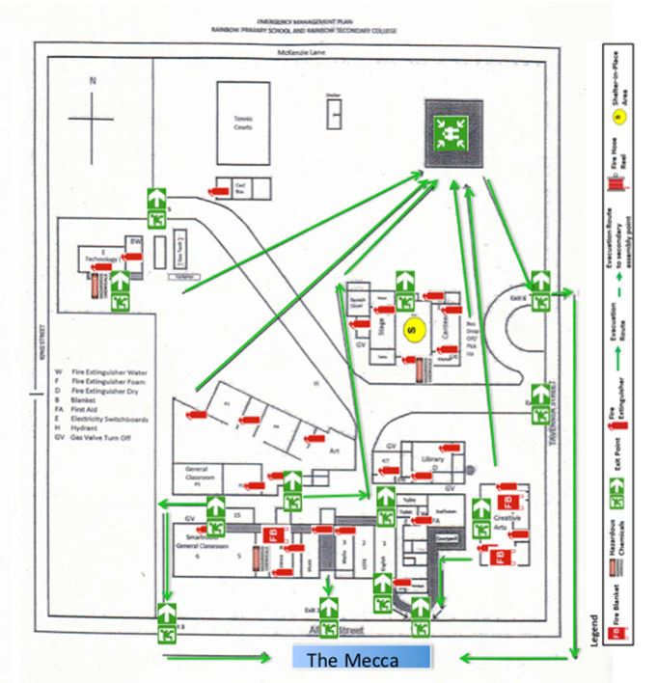

Signatures:

Workplace Manager/Management OHS Nominee………………………………………………Date…………………….

Health and Safety Representative……………………………………………………………….. Date…………………….

Person completing TMP……………………………………………………………………………Date…………………….

